Interior Angles
# Source: AI Source: Provided by: [Data Path: Persons Table -> ID Column: 1, Name_En Column: Motasem Essam] -> From: [ChatGPT] on [7/25/2026]
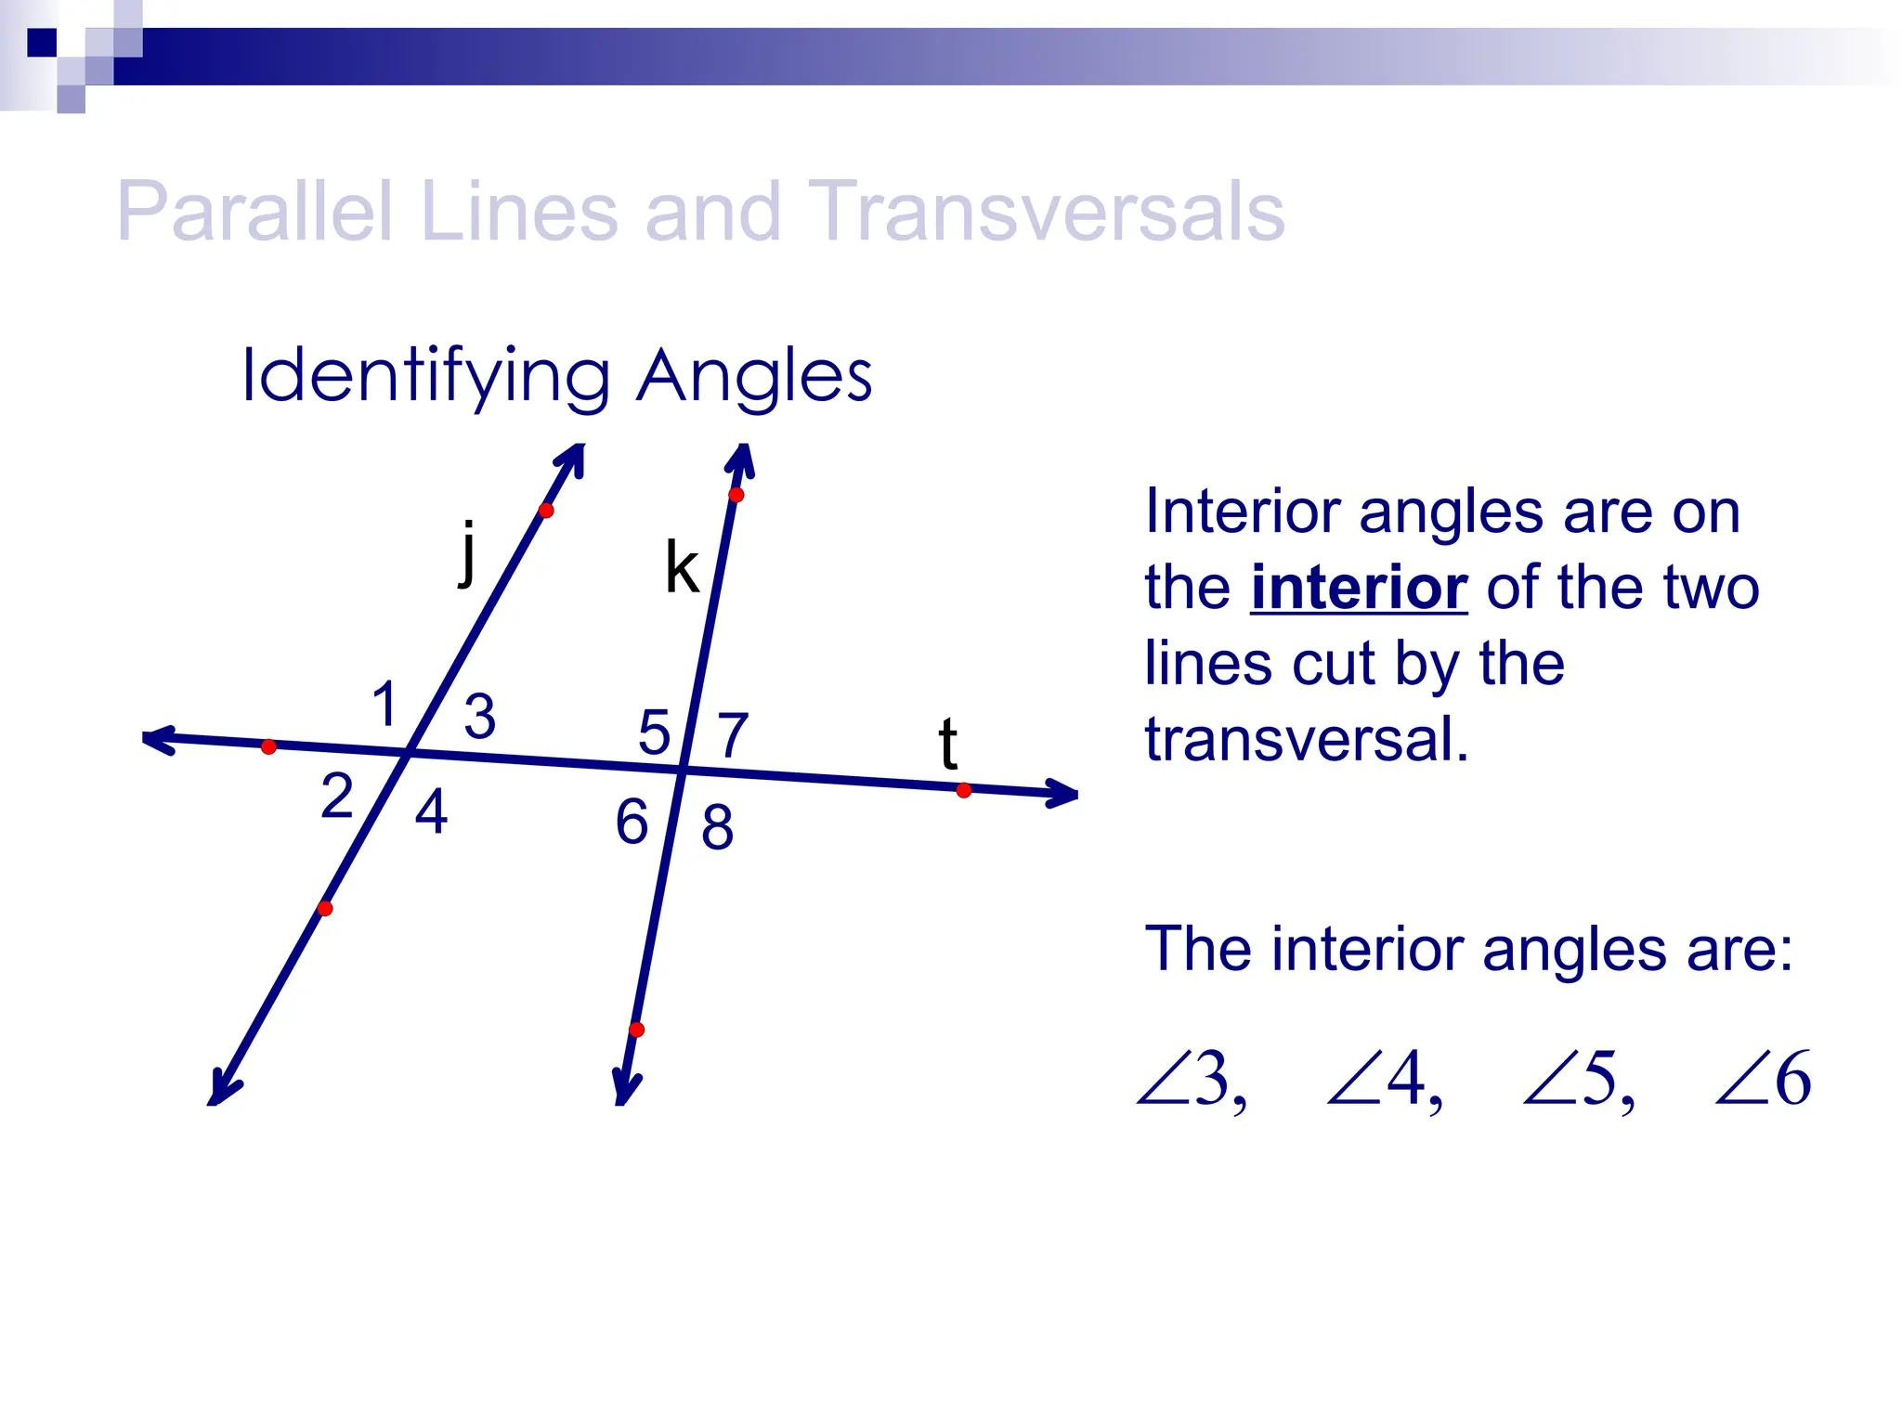
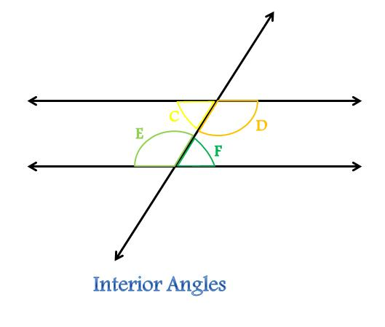
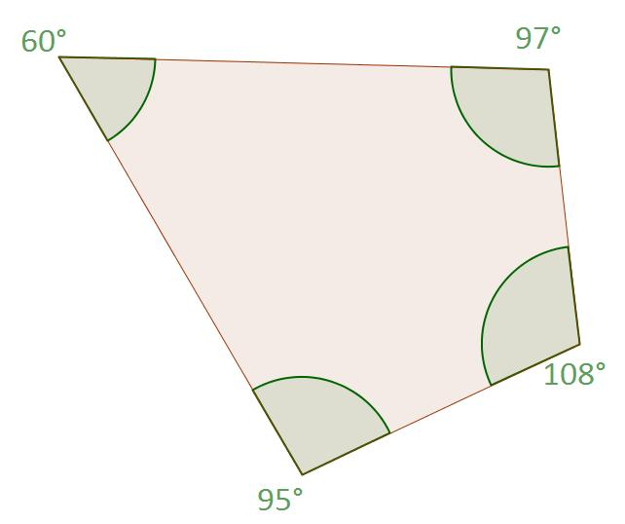
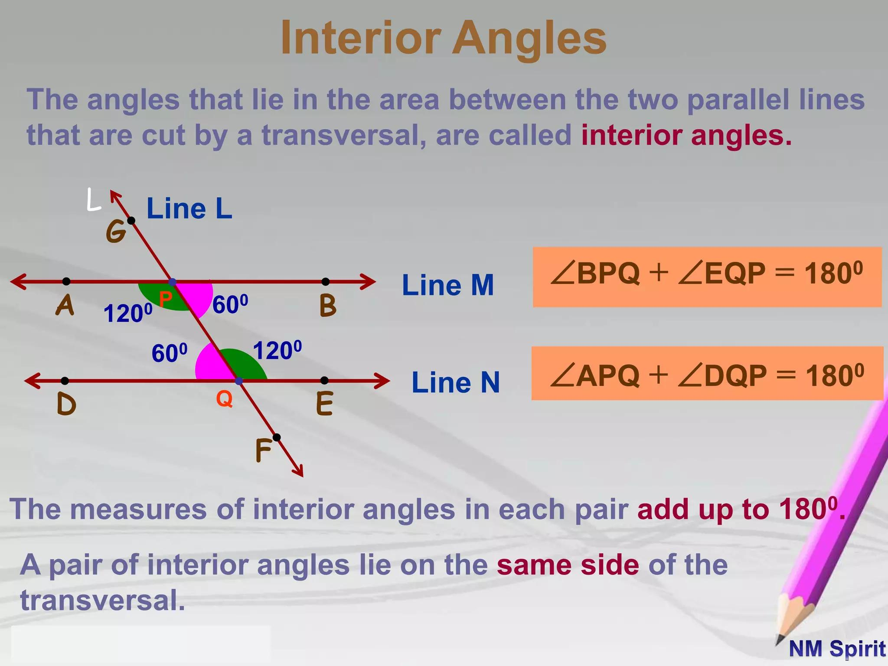
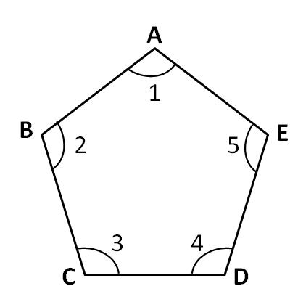

Definition
# Source: AI Source: Provided by: [Data Path: Persons Table -> ID Column: 1, Name_En Column: Motasem Essam] -> From: [ChatGPT] on [7/25/2026]
Interior Angles are angles located inside a geometric figure or between two lines. The exact meaning depends on the geometric context:
- In polygons, interior angles are the angles formed inside the boundary of the polygon.
- In parallel-line geometry, interior angles are the angles located between two lines when they are intersected by a transversal.
Interior angles describe the internal shape and structure of geometric figures.

Characteristics
# Source: AI Source: Provided by: [Data Path: Persons Table -> ID Column: 1, Name_En Column: Motasem Essam] -> From: [ChatGPT] on [7/25/2026]
Interior angles:
- Are located inside a geometric figure or region.
- Share a common vertex with two sides or rays.
- Can be measured in degrees or radians.
- Their relationships depend on the type of figure.

Interior Angles in Polygons
# Source: AI Source: Provided by: [Data Path: Persons Table -> ID Column: 1, Name_En Column: Motasem Essam] -> From: [ChatGPT] on [7/25/2026]
An interior angle of a polygon is formed by two adjacent sides inside the polygon.

Triangle
# Source: AI Source: Provided by: [Data Path: Persons Table -> ID Column: 1, Name_En Column: Motasem Essam] -> From: [ChatGPT] on [7/25/2026]
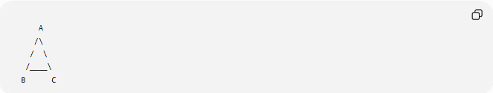
A
/\
/ \
/____\
B C
The interior angles are:
$$∠A, ∠B, ∠C$$
The sum of the interior angles is:
$$∠A+∠B+∠C={180}^{∘}$$

Quadrilateral
# Source: AI Source: Provided by: [Data Path: Persons Table -> ID Column: 1, Name_En Column: Motasem Essam] -> From: [ChatGPT] on [7/25/2026]
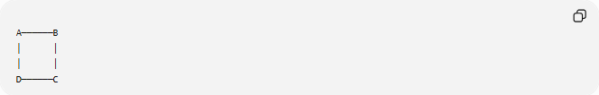
A──────B
│ │
│ │
D──────C
Interior angles:
$$∠A,∠B,∠C,∠D$$
Their sum is:
$${360}^{∘}$$

General Polygon
# Source: AI Source: Provided by: [Data Path: Persons Table -> ID Column: 1, Name_En Column: Motasem Essam] -> From: [ChatGPT] on [7/25/2026]
For a polygon with (n) sides, the sum of the interior angles is:
$$\left(n-2\right)×{180}^{∘}$$

Interior Angles Between Parallel Lines
# Source: AI Source: Provided by: [Data Path: Persons Table -> ID Column: 1, Name_En Column: Motasem Essam] -> From: [ChatGPT] on [7/25/2026]
When a transversal intersects two lines, the interior angles are the angles located between the two lines.
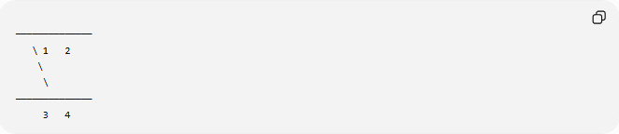
──────────────
\ 1 2
\
\
──────────────
3 4
The interior angles are:
$$∠2, ∠3$$
and
$$∠1, ∠4$$
depending on the labeling convention.
These interior angles form special relationships such as:
- Alternate Interior Angles
- Same-Side Interior Angles

Mathematical Representation
# Source: AI Source: Provided by: [Data Path: Persons Table -> ID Column: 1, Name_En Column: Motasem Essam] -> From: [ChatGPT] on [7/25/2026]
Polygon Interior Angle Sum
$$S=\left(n-2\right)×{180}^{∘}$$
where:
- $S$ = sum of interior angles
- $n$ = number of sides

Regular Polygon
Each interior angle is:
$$\frac{\left(n-2\right)×{180}^{∘}}{n}$$

Examples
# Source: AI Source: Provided by: [Data Path: Persons Table -> ID Column: 1, Name_En Column: Motasem Essam] -> From: [ChatGPT] on [7/25/2026]
Triangle
$${60}^{∘}+{70}^{∘}+{50}^{∘}={180}^{∘}$$

Pentagon
Number of sides:
$$n=5$$
Sum:
$$\left(5-2\right)×{180}^{∘}={540}^{∘}$$

Hexagon
$$\left(6-2\right)×{180}^{∘}={720}^{∘}$$

Interior Angle Relationships

Alternate Interior Angles
# Source: AI Source: Provided by: [Data Path: Persons Table -> ID Column: 1, Name_En Column: Motasem Essam] -> From: [ChatGPT] on [7/25/2026]
If two parallel lines are cut by a transversal:
- Alternate interior angles are equal.

Same-Side Interior Angles
# Source: AI Source: Provided by: [Data Path: Persons Table -> ID Column: 1, Name_En Column: Motasem Essam] -> From: [ChatGPT] on [7/25/2026]
If two parallel lines are cut by a transversal:
- Same-side interior angles are supplementary.
$$θ_{1}+θ_{2}={180}^{∘}$$

Real-World Examples
# Source: AI Source: Provided by: [Data Path: Persons Table -> ID Column: 1, Name_En Column: Motasem Essam] -> From: [ChatGPT] on [7/25/2026]
Interior angles appear in:
- Triangles.
- Squares.
- Rectangles.
- Pentagons.
- Hexagons.
- Building floor plans.
- Engineering drawings.
- Tile patterns.
- Bridges.

Applications
# Source: AI Source: Provided by: [Data Path: Persons Table -> ID Column: 1, Name_En Column: Motasem Essam] -> From: [ChatGPT] on [7/25/2026]
Interior angles are used in:
- Plane Geometry
- Polygon Geometry
- Coordinate Geometry
- Engineering
- Architecture
- Construction
- Surveying
- CAD (Computer-Aided Design)
- Robotics
- Computer Graphics

Advantages
# Source: AI Source: Provided by: [Data Path: Persons Table -> ID Column: 1, Name_En Column: Motasem Essam] -> From: [ChatGPT] on [7/25/2026]
Studying interior angles helps to:
- Classify polygons.
- Determine missing angles.
- Solve geometric proofs.
- Design geometric structures.
- Analyze parallel-line relationships.

Limitations
# Source: AI Source: Provided by: [Data Path: Persons Table -> ID Column: 1, Name_En Column: Motasem Essam] -> From: [ChatGPT] on [7/25/2026]
Interior-angle properties depend on the geometric context:
- In polygons, their sum depends on the number of sides.
- Between parallel lines, their relationships depend on whether the lines are parallel.

Comparison with Related Concepts
# Source: AI Source: Provided by: [Data Path: Persons Table -> ID Column: 1, Name_En Column: Motasem Essam] -> From: [ChatGPT] on [7/25/2026]
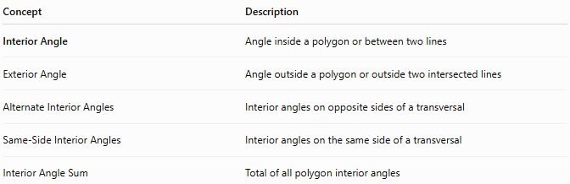
Concept | Description
Interior Angle | Angle inside a polygon or between two lines
Exterior Angle | Angle outside a polygon or outside two intersected lines
Alternate Interior Angles | Interior angles on opposite sides of a transversal
Same-Side Interior Angles | Interior angles on the same side of a transversal
Interior Angle Sum | Total of all polygon interior angles

Key Points
# Source: AI Source: Provided by: [Data Path: Persons Table -> ID Column: 1, Name_En Column: Motasem Essam] -> From: [ChatGPT] on [7/25/2026]
- Interior Angles are located inside a polygon or between two intersected lines.
- The sum of the interior angles of an (n)-sided polygon is:
$$\left(n-2\right)×{180}^{∘}$$
- In parallel-line geometry:
  - Alternate interior angles are equal.
  - Same-side interior angles are supplementary.

Conclusion
# Source: AI Source: Provided by: [Data Path: Persons Table -> ID Column: 1, Name_En Column: Motasem Essam] -> From: [ChatGPT] on [7/25/2026]
Interior Angles are angles found inside geometric figures or between two lines intersected by a transversal. They play a central role in understanding the properties of polygons and the relationships created by parallel lines. Interior angles are fundamental in plane geometry, polygon geometry, coordinate geometry, engineering, architecture, construction, surveying, CAD, robotics, and computer graphics, where they are used to analyze shapes, determine unknown measurements, and construct accurate geometric designs.

